|  |  |
| --- | --- |
| **Topic** | Apache Kafka |
| **Document Name** | KAFKA-EX-02 |
|  |  |

|  |  |  |  |
| --- | --- | --- | --- |
| **Document Difficulty Level** | | | |
| **Beginner** | **Junior** | **Senior** | **Expert** |
| □ | ■ | □ | □ |

# Document History

|  |  |  |  |
| --- | --- | --- | --- |
| Date | Author | Ver | Comments |
| **05.03.2025** | Mennan Tekbir | 1.0 | Initial Draft |
| **05.03.2025** | Mehmet Erdem Önal | 1.1 | Revisions |

# Apache Kafka

## Exercise KAFKA-EX-02:

**Definiton:** Pull & run Kafka container from Docker Hub in your GCP or AWS cloud machine. (You can use confluent oﬀcial docker- [repo](https://github.com/confluentinc/cp-all-in-one/tree/7.5.0-post/cp-all-in-one) ). For being more practical, you can run in your local machine first, and then, you can switch to cloud machine.

**Note:** If you did not get a cloud machine previously, you may simply run it on your local machine.

**Hint:** [Run Apache Kafka using Docker](https://www.youtube.com/watch?v=8ZTTcAWMIAE)

Please provide screenshots to show your work.

## KAFKA-EX-02 Solution:

**Your Answer:**

You may provide scre**My Kafka Assignment – Steps**

1)First, I created a Docker network named kafka-net so that Kafka and Zookeeper containers could communicate with each other.

2)Then, I ran the Zookeeper container connected to this network and exposed port 2181 to the host.

3)After that, I ran the Kafka container with the necessary environment variables set correctly (such as KAFKA_ZOOKEEPER_CONNECT, KAFKA_BROKER_ID, KAFKA_LISTENERS, etc.) to connect Kafka to Zookeeper.

4)Once the Kafka container started successfully, I verified that both Zookeeper and Kafka containers were running by using the docker ps command.

5)Finally, I confirmed that Kafka was accessible externally by checking that port 9092 was open and the container was running without errors.

6)I took screenshots of the running containers and included them in my assignment file.

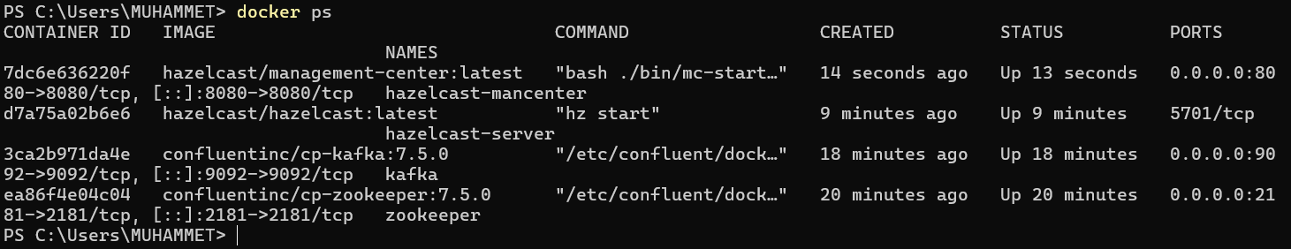

Kafka connection test

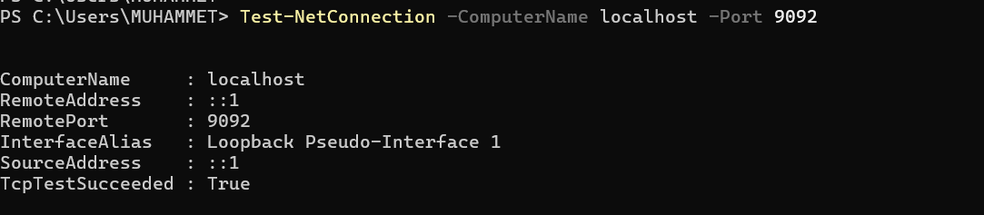

c